Exercise 9:

ListOfPlayers.js:
// src/components/ListOfPlayers.js
import React from 'react';

const ListOfPlayers = () => {
const players = [
{ name: "Virat", score: 95 },
{ name: "Rohit", score: 88 },
{ name: "Dhoni", score: 70 },
{ name: "Jadeja", score: 67 },
{ name: "Pant", score: 92 },
{ name: "Bumrah", score: 85 },
{ name: "Shami", score: 78 },
{ name: "Gill", score: 65 },
{ name: "Ishan", score: 60 },
{ name: "Ashwin", score: 72 },
{ name: "Surya", score: 99 },
];

// Filter players with score < 70 using arrow function
const below70 = players.filter(player => player.score < 70);

return (
<div>
<h2>All Players</h2>
<ul>
{players.map((player, index) => (
<li key={index}>{player.name} - {player.score}</li>
))}
</ul>

<h2>Players with Score Below 70</h2>
<ul>
{below70.map((player, index) => (
<li key={index}>{player.name} - {player.score}</li>
))}
</ul>
</div>
);
};

export default ListOfPlayers;

IndianPlayers.js:
// src/components/IndianPlayers.js
import React from 'react';

const IndianPlayers = () => {
const players = [
"Virat", "Rohit", "Dhoni", "Jadeja", "Pant",
"Bumrah", "Shami", "Gill", "Ishan", "Ashwin", "Surya"
];

// Destructure players into even and odd index teams
const oddTeam = players.filter((_, index) => index % 2 !== 0);
const evenTeam = players.filter((_, index) => index % 2 === 0);

// Merge arrays
const T20Players = ["Virat", "Rohit", "Pant"];
const RanjiPlayers = ["Pujara", "Rahane", "Saha"];
const mergedPlayers = [...T20Players, ...RanjiPlayers];

return (
<div>
<h2>Odd Team Players</h2>
<ul>
{oddTeam.map((player, index) => (
<li key={index}>{player}</li>
))}
</ul>

<h2>Even Team Players</h2>
<ul>
{evenTeam.map((player, index) => (
<li key={index}>{player}</li>
))}
</ul>

<h2>Merged Team: T20 + Ranji Trophy Players</h2>
<ul>
{mergedPlayers.map((player, index) => (
<li key={index}>{player}</li>
))}
</ul>
</div>
);
};

export default IndianPlayers;

App.js:
// src/App.js
import React from 'react';
import ListOfPlayers from './components/ListOfPlayers';
import IndianPlayers from './components/IndianPlayers';

function App() {
const flag = true; // Change to false to see IndianPlayers

return (
<div className="App">
<h1>🏏 Cricket App</h1>
{flag ? <ListOfPlayers /> : <IndianPlayers />}
</div>
);
}

export default App;

Output:
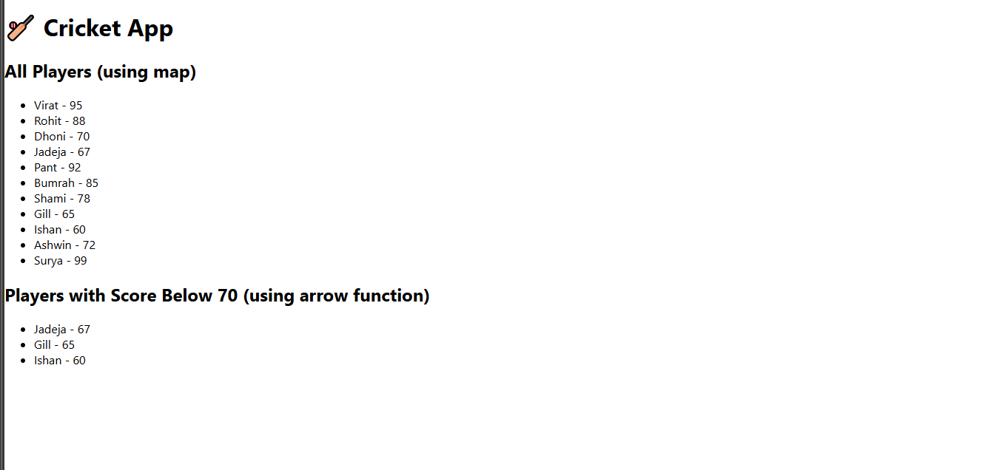
App.js:
import React from 'react';
import ListOfPlayers from './components/ListOfPlayers';
import IndianPlayers from './components/IndianPlayers';

function App() {
const flag = false; // Change to false to see IndianPlayers instead

return (
<div className="App">
<h1>🏏 Cricket App</h1>
{flag ? <ListOfPlayers /> : <IndianPlayers />}
</div>
);
}

export default App;

Output:

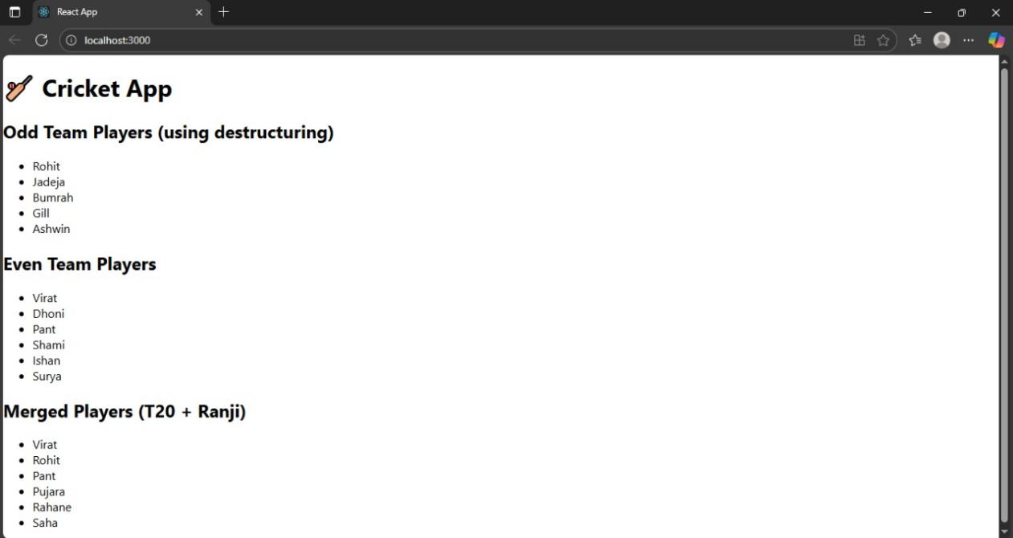

Exercise 10:

App.js:
import './App.css';

function App() {
const heading = <h1>Office Space Rental</h1>;

const imageUrl = "https://content.instantoffices.com/sc/Prod/images/centres/1600width/119356/119356-810995.jpg";

const image = (
<div style={{ textAlign: "center", margin: "20px 0" }}>
<img
src={imageUrl}
alt="Office Space"
style={{
width: "300px",
height: "200px",
objectFit: "cover",
borderRadius: "10px",
boxShadow: "0 4px 8px rgba(0,0,0,0.2)"
}}
/>
</div>
);

const offices = [
{ name: "Orchid Tech Park", rent: 55000, address: "Whitefield" },
{ name: "Prestige Shantiniketan", rent: 75000, address: "ITPL" },

];

return (
<div style={{ padding: "20px", fontFamily: "Arial" }}>
{heading}
{image}

{offices.map((office, index) => (
<div
key={index}
style={{
border: "1px solid black",
margin: "10px auto",
padding: "10px",
maxWidth: "500px",
textAlign: "left",
borderRadius: "8px"
}}
>
<h2>{office.name}</h2>
<p>Address: {office.address}</p>
<p style={{ color: office.rent < 60000 ? 'red' : 'green' }}>
Rent: ₹{office.rent}
</p>
</div>
))}
</div>
);
}

export default App;

Output:

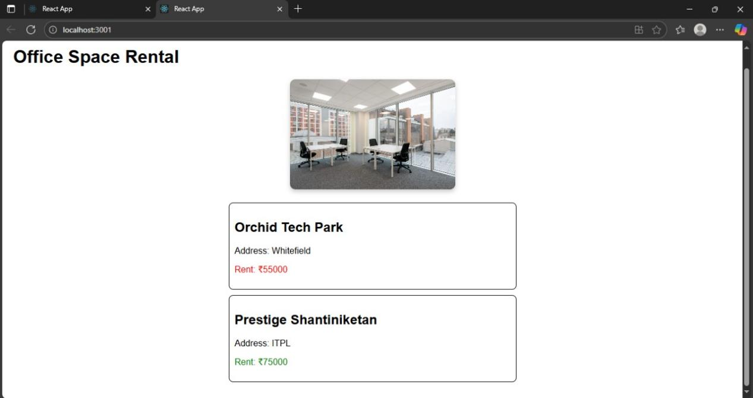

Exercise 11:

App.js:
import React from 'react';
import './App.css';
import CurrencyConvertor from './CurrencyConvertor';

class App extends React.Component {
constructor() {
super();
this.state = {
count: 0
};
}

increment = () => {
this.setState({ count: this.state.count + 1 });
};

sayHello = () => {
alert("Hello! This is a static message.");
};

handleIncrementClick = () => {
this.increment();
this.sayHello();
};

decrement = () => {
this.setState({ count: this.state.count - 1 });
};

sayWelcome = (message) => {
alert(Welcome! ${message});
};

handleSyntheticEvent = (event) => {
event.preventDefault();
alert("I was clicked");
};

render() {
return (
<div className="App">
<h2>Counter: {this.state.count}</h2>
<button onClick={this.handleIncrementClick}>Increment</button>
<button onClick={this.decrement}>Decrement</button>

<br /><br />
<button onClick={() => this.sayWelcome("Welcome to React!")}>Say Welcome</button>

<br /><br />
<button onClick={this.handleSyntheticEvent}>OnPress</button>

<hr />
<CurrencyConvertor />
</div>
);
}
}

export default App;

CurrencyConvertor.js:
import React, { Component } from 'react';

class CurrencyConvertor extends Component {
constructor() {
super();
this.state = {
rupees: '',
euro: ''
};
}

handleChange = (event) => {
this.setState({ rupees: event.target.value });
};

handleSubmit = (event) => {
event.preventDefault();
const euroValue = (parseFloat(this.state.rupees) / 90).toFixed(2); // Assuming 1 Euro = 90 INR
this.setState({ euro: euroValue });
};

render() {
return (
<div>
<h3>Currency Converter (INR to EURO)</h3>
<form onSubmit={this.handleSubmit}>
<input
type="number"
value={this.state.rupees}
onChange={this.handleChange}
placeholder="Enter amount in INR"
/>
<button type="submit">Convert</button>
</form>
<p>Converted Value: €{this.state.euro}</p>
</div>
);
}
}

export default CurrencyConvertor;

Output:

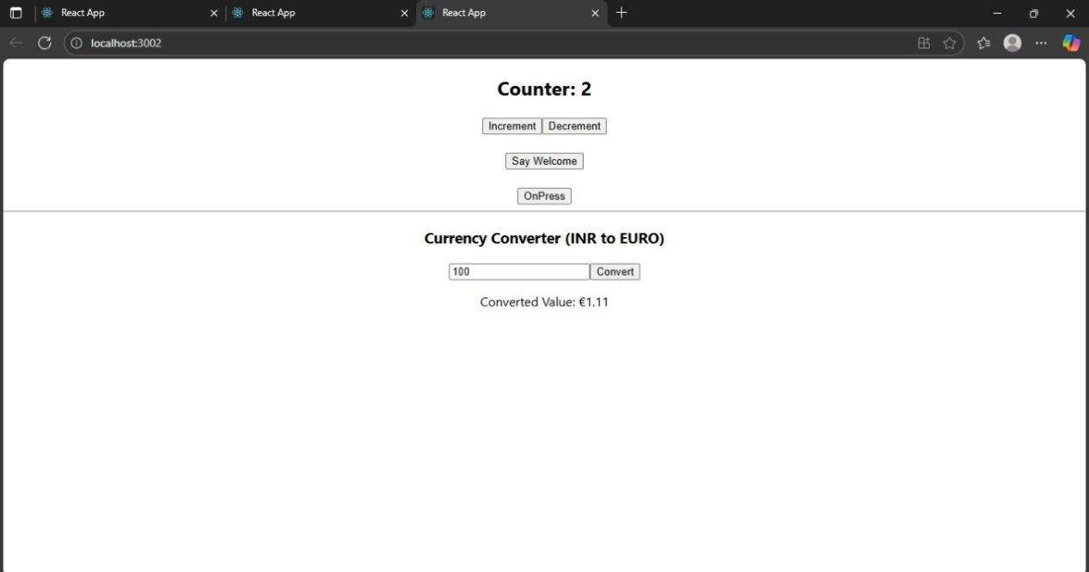

Exercise 12:

GuestPage.js:
import React from 'react';
import FlightDetails from './FlightDetails';

function GuestPage() {
return (
<div>
<h2>Welcome Guest!</h2>
<p>Please log in to book tickets.</p>
<FlightDetails />
</div>
);
}

export default GuestPage;

UserPage.js:
import React from 'react';
import FlightDetails from './FlightDetails';

function UserPage() {
return (
<div>
<h2>Welcome User!</h2>
<p>You can now book your tickets.</p>
<FlightDetails />
<button>Book Ticket</button>
</div>
);
}

export default UserPage;

FlightDetails.js:
import React from 'react';

function FlightDetails() {
return (
<div>
<h3>Flight Details</h3>
<ul>
<li>Flight: AI-202 | From: Delhi | To: Mumbai | Time: 10:00 AM</li>
<li>Flight: AI-203 | From: Chennai | To: Bangalore | Time: 12:00 PM</li>
</ul>
</div>
);
}

export default FlightDetails;

LoginButton.js:
function LoginButton({ onClick }) {
return <button onClick={onClick}>Login</button>;
}

export default LoginButton;

LogoutButton.js:
function LogoutButton({ onClick }) {
return <button onClick={onClick}>Logout</button>;
}

export default LogoutButton;

App.js:
import React, { useState } from 'react';
import GuestPage from './components/GuestPage';
import UserPage from './components/UserPage';
import LoginButton from './components/LoginButton';
import LogoutButton from './components/LogoutButton';

function App() {
const [isLoggedIn, setIsLoggedIn] = useState(false);

const handleLoginClick = () => setIsLoggedIn(true);
const handleLogoutClick = () => setIsLoggedIn(false);

let page;
let button;

if (isLoggedIn) {
page = <UserPage />;
button = <LogoutButton onClick={handleLogoutClick} />;
} else {
page = <GuestPage />;
button = <LoginButton onClick={handleLoginClick} />;
}

return (
<div className="App">
<h1>✈ Ticket Booking App</h1>
{button}
{page}
</div>
);
}

export default App;

Output:
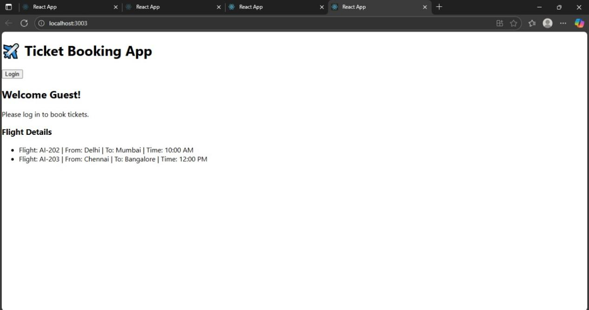

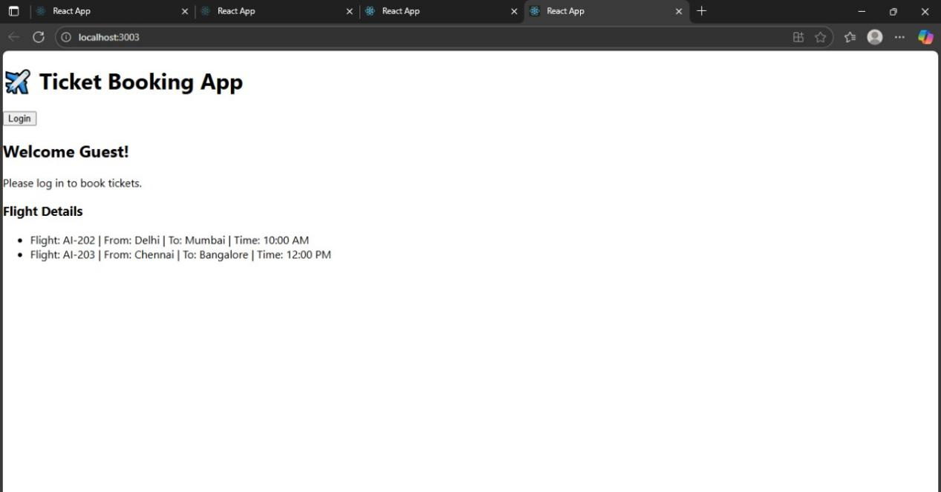

Exercise 13:

Data .js:
export const books = [
{ id: 101, bname: 'Master React', price: 670 },
{ id: 102, bname: 'Deep Dive into Angular 11', price: 800 },
{ id: 103, bname: 'Mongo Essentials', price: 450 }
];
export const blogs = [
{
id: 1,
title: 'React Learning',
author: 'Stephen Biz',
content: 'Welcome to learning React!'
},
{
id: 2,
title: 'Installation',
author: 'Schwezdenier',
content: 'You can install React from npm.'
}
];
export const courses = [
{ id: 1, cname: 'Angular', date: '4/5/2021' },
{ id: 2, cname: 'React', date: '6/3/20201' }
];

App.js:
import React from 'react';
import './App.css';
import { books, blogs, courses } from './data';
function App() {
const bookdet = (
<ul>
{books.map((book) => (
<div key={book.id}>
<h3>{book.bname}</h3>
<h4>{book.price}</h4>
</div>
))}
</ul>
);
const content = (
<ul>
{blogs.map((blog) => (
<div key={blog.id}>
<h3>{blog.title}</h3>
<h5><strong>{blog.author}</strong></h5>
<p>{blog.content}</p>
</div>
))}
</ul>
);
const coursedet = (
<ul>
{courses.map((course) => (
<div key={course.id}>
<h3>{course.cname}</h3>
<h4>{course.date}</h4>
</div>
))}
</ul>
);
return (
<div className="container">
<div className="mystyle1">
<h1>Course Details</h1>
{coursedet}
</div>

<div className="st2">
<h1>Book Details</h1>
{bookdet}
</div>
<div className="v1">
<h1>Blog Details</h1>
{content}
</div>
</div>
);
}
export default App;

App.css:
.container {
display: flex;
justify-content: space-around;
padding: 40px;
}
.mystyle1, .st2, .v1 {
padding: 10px;
width: 30%;
font-family: Arial, sans-serif;
}
.st2, .v1 {
border-left: 5px solid green;
}

Output:
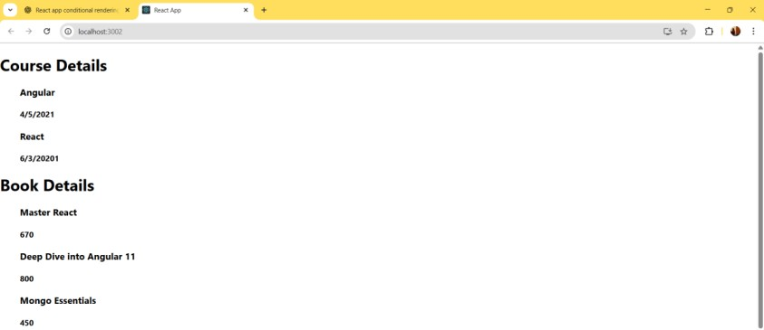

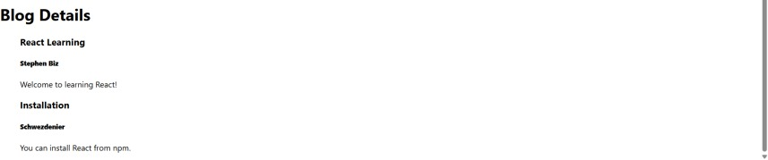

Additional hands_on:
Exercise 14:

ThemeContext.js:
import { createContext } from 'react';

// Step: create a context with default value 'light'
const ThemeContext = createContext('light');

export default ThemeContext;

App.js:
import React, { useState } from 'react';
import EmployeeList from './EmployeeList';
import ThemeContext from './ThemeContext';

function App() {
const [theme, setTheme] = useState('light');

return (
<ThemeContext.Provider value={theme}>
<div style={{ padding: '20px' }}>
<h1>Employee Management</h1>
<button onClick={() => setTheme(theme === 'light' ? 'dark' : 'light')}>
Toggle Theme
</button>
<EmployeeList />
</div>
</ThemeContext.Provider>
);
}

export default App;

EmployeeList.js:
import React from 'react';
import EmployeeCard from './EmployeeCard';

function EmployeeList() {
const employees = [
{ id: 1, name: 'Alice', designation: 'Developer' },
{ id: 2, name: 'Bob', designation: 'Designer' }
];

return (
<div>
{employees.map(emp => (
<EmployeeCard key={emp.id} employee={emp} />
))}
</div>
);
}

export default EmployeeList;

EmployeeCard.js:
import React, { useContext } from 'react';
import ThemeContext from './ThemeContext';

function EmployeeCard({ employee }) {
const theme = useContext(ThemeContext); // use context to get theme

const buttonClass =
theme === 'dark' ? 'btn btn-dark' : 'btn btn-light';

const cardStyle = {
border: '1px solid #ccc',
margin: '10px',
padding: '10px',
borderRadius: '8px'
};

return (
<div style={cardStyle}>
<h4>{employee.name}</h4>
<p>{employee.designation}</p>
<button className={buttonClass}>View Profile</button>
</div>
);
}

export default EmployeeCard;

index.css:
.btn {
padding: 10px 20px;
border: none;
margin-top: 10px;
cursor: pointer;
font-weight: bold;
border-radius: 4px;
}

.btn-light {
background-color: #f0f0f0;
color: black;
}

.btn-dark {
background-color: black;
color: white;
}

index.js:
import React from 'react';
import ReactDOM from 'react-dom/client';
import './index.css';
import App from './App';

const root = ReactDOM.createRoot(document.getElementById('root'));
root.render(<App />);

Output:
